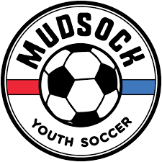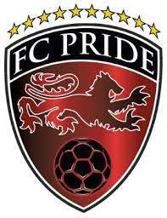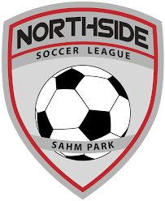

North Central Recreational Soccer League
Fall 2023 Tournament
Parent & Spectator Behavior Guidance
Glendale Soccer, Mudsock Youth Sport, FC Pride & Northside Soccer
October 27 - 29, 2023

Glendale Soccer, Mudsock Youth Sports, FC Pride and Northside Soccer appreciate the support that all parents and family members provide to their children during their participation with the North Central Recreation Soccer League. The role that parents and family members play in the life of a soccer player has a tremendous impact on his/her soccer experience. We would like to make sure that your influence for our upcoming Fall 2023 tournament is a positive one.

Our club’s have made it clear that parents, coaches and players will be monitored for proper on-the-field and sideline behavior. Below are some simple rules that all tournament spectators need to observe and consider carefully before arriving at our tournament.
- For parents that have questions or concerns with any matter related to the tournament, discuss them with your respective team’s coach first. The coach will relay those concerns to the club’s program director. The club’s program director will communicate those questions or concerns with the tournament director. The club’s program director will follow-up with the coach to report on any actions required.

- Parents should not shout insults or verbally abuse referees, coaches of either team, opposing team members or parents. Parents should be in control of their emotions at all times, always showing respect and setting a proper example for their own children. Parents that are angry or upset should leave the field until they can get control over their emotions.

- Players and coaches of both teams shall occupy the same side of the field. All spectators shall occupy the opposite side of the field across from the team they support. No spectators will be allowed behind a goal during a match. If in the opinion of the referee, a spectator is deemed in breach of these requirements, the referee is empowered to demand the spectator leave the area of the field before the game resumes.
- Parents will refrain from entering the field of play at any time, unless authorized by a match official. In order to avoid confrontations with other team parents and maintain team cohesion, parents should also refrain from publicly criticizing the play of other teams or their players.

- Parents are responsible for their guests’ behavior and must inform their guests of the applicable rules of conduct.

Parents, as well as coaches and players alike, will be held responsible for their decisions and actions. If a rule is considered broken by a referee, match official or program director, parents may be suspended from being at the field during the child’s next match. Additional sanctions may be rendered on teams.

Knowing the Laws of Soccer:

A misunderstanding of the laws of soccer can often lead to inappropriate comments directed at referees. We know that referees may not always make the correct call or miss something that happens on the field – but it never gives anyone the right to disrespect or abuse them. Our NCRSL referees are amateurs, many of whom get involved in youth soccer for their love of the game or they are players themselves. They give their time and expertise for little to no money. By treating referees with respect from the sidelines, you help create a more positive environment for all to enjoy the tournament.

We encourage you to take a few minutes to review the laws of the game, including what constitutes a foul, handball and offsides or when the ball is fully out of play. A short rules tutorial of youth soccer rules can be found HERE.

Before Heading to a Match:

Youth soccer is for the players. Please keep in mind that we are recreational soccer programs with the following goal in mind – provide a safe, fun and fair atmosphere for kids to play soccer.
Derogatory or harassing comments regarding players, coaches, referees or fellow parents are unacceptable. Parents are asked to keep their comments regarding the actions or play of the game positive and uplifting for all players regardless of club affiliation.
We invite you to share in the pleasure of watching and cheering on your children in this season’s tournament.

Glendale Soccer
Mudsock Youth Sports
FC Pride
Northside Soccer

